WEEK 10

A set of experiments runs was to determine a way of predicting cooking time y at various values of oven width x1 and temperature x2 the coded data was reported as follows
Oven width
Oven width | Flux temperature | Cooking temperature
1.32 | 1.15 | 6.40
2.69 | 3.40 | 15.05
3.56 | 4.10 | 18.75
4.41 | 8.75 | 0.25
535 | 14.82 | 44.85
6.20 | 15.15 | 48.94
7.12 | 15.32 | 51.55
8.87 | 18.18 | 60.50
9.80 | 35.19 | 100.44
10.65 | 40.40 | 111.42

Code:
O=c(1.32,2.69,3.56,4.41,5.35,6.20,7.12,8.87,9.80,10.65)
Fl=c(1.15,3.40,4.10,8.75,14.82,15.15,15.32,18.18,35.19,40.40)
C=c(6.40,15.05,18.75,0.25,44.85,48.94,51.55,60.50,100.44,111.42)
dataone=data.frame(O,Fl,C)
multireg=lm(C~O+Fl)
multireg
dataone=with(trees,scatterplot3d(O,F,C,pch=16,highlight.3d=TRUE,angle=60))
ftt=lm(C~O+Fl,data = trees)
dataone$plane3d(ftt)
dataone$plane3d(ftt)
dataone=data.frame(O,Fl,C)
m2=cor(dataone,method="pearson")
m2
partial.r(m2,c(1,3),2)
Output:
> O=c(1.32,2.69,3.56,4.41,5.35,6.20,7.12,8.87,9.80,10.65)
> Fl=c(1.15,3.40,4.10,8.75,14.82,15.15,15.32,18.18,35.19,40.40)
> C=c(6.40,15.05,18.75,0.25,44.85,48.94,51.55,60.50,100.44,111.42)
> dataone=data.frame(O,Fl,C)
> multireg=lm(C~O+Fl)
> multireg

Call:
lm(formula = C ~ O + Fl)

Coefficients:
(Intercept) O Fl
-4.391 2.632 2.200

> dataone=with(trees,scatterplot3d(O,F,C,pch=16,highlight.3d=TRUE,angle=60))
> ftt=lm(C~O+Fl,data = trees)
> dataone$plane3d(ftt)
> dataone=data.frame(O,Fl,C)
> m2=cor(dataone,method="pearson")
> m2
O Fl C
O 1.0000000 0.9375592 0.9315911
Fl 0.9375592 1.0000000 0.9656362
C 0.9315911 0.9656362 1.0000000
> partial.r(m2,c(1,3),2)
partial correlations
O C
O 1.00 0.29
C 0.29 1.00

Graph:
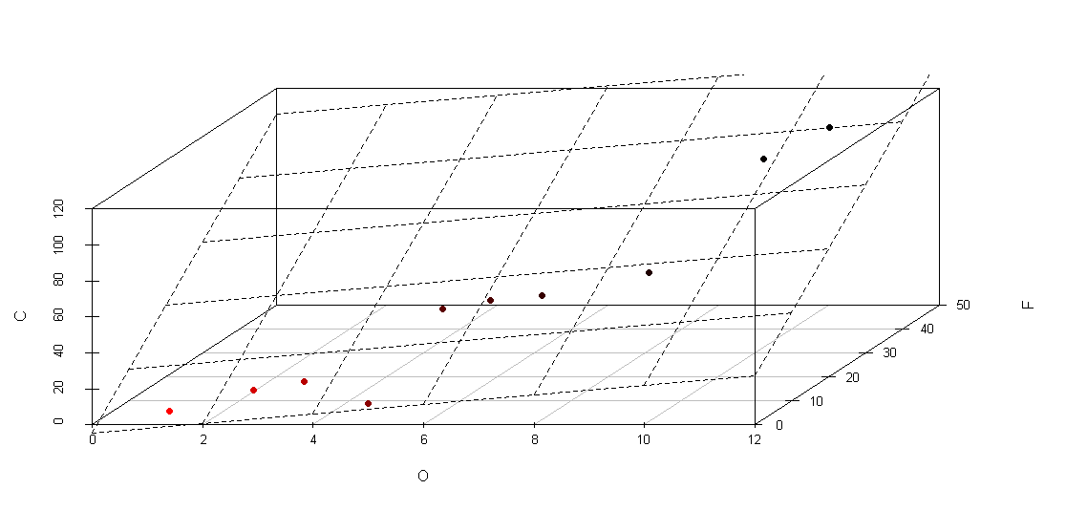

2. Find the partial correlation r_{12.3} to the following set of data
x1 :23,27,28,28,29,30,31,33,35,36
y1:18,20,22,27,21,29,27,29,28,29
z1=15,25,35,45,55,65,67,74,55,42

code:
x1=c(23,27,28,28,29,30,31,33,35,36)
y1=c(18,20,22,27,21,29,27,29,28,29)
z1=c(15,25,35,45,55,65,67,74,55,42)
data1=data.frame(x1,y1,z1)
mat=cor(data1,method="pearson")
mat
partial.r(mat,c(1,2),3)

Output:
> x1=c(23,27,28,28,29,30,31,33,35,36)
> y1=c(18,20,22,27,21,29,27,29,28,29)
> z1=c(15,25,35,45,55,65,67,74,55,42)
> data1=data.frame(x1,y1,z1)
> mat=cor(data1,method="pearson")
> mat
x1 y1 z1
x1 1.0000000 0.8176052 0.6280975
y1 0.8176052 1.0000000 0.7636542
z1 0.6280975 0.7636542 1.0000000
> partial.r(mat,c(1,2),3)
partial correlations
x1 y1
x1 1.00 0.67
y1 0.67 1.00

Result:
The partial correlation was successfully computed.

